

Application Programming PracticAL File

INDIAN INSTITUTE OF INFORMATION TECHNOLOGY , SONEPAT



June 17, 2020

NAME : NILESH GUPTA

ROLL NO. : 11912015

BRANCH : IT

**INDEX**

|  |  |  |
| --- | --- | --- |
| SR.  NO. | PROGRAM NAME | PAGE NO. |
| 1. | Write a program for creating HTML Form | 2-4 |
| 2. | Write a program for creating HTML Homepage using Bootstrap 4.5 | 5-9 |
| 3. | Write a program to understand working of API using fetch and promises & handling the response using Async_Await | 10-17 |
| 4. | Setting up and configuration of apache and mysql server using XAMPP | 18-22 |
| 5. | Write a program to understand the XMLHttp request for fetching the data | 23-28 |
| 6. | Write a program for Creating Website using PHP (Simple Registration Webpage) | 29-33 |
| **7.** | Write a program to understand the JavaScript (Loan Calculator Project) using Bootstrap 4.5 | 34-42 |
| **8.** | Create web application which has front-end in JS and back-end in PHP which runs from apache local server | 43-51 |

$Write a program for creating HTML Form using Bootstrap 4.0$

1

CODE :

<!DOCTYPE html>

<html>

  <head>

    <title>My Form</title>

  </head>

  <body>

    <br />

    <form>

      <fieldset>

        <legend>Personal Information :</legend>

        <p>

          <label for="name">Name :</label>

          <input

            type="text"

            name="name"

            id="name"

            maxlength="20"

            autofocus

            required

            placeholder="Your Name"

          />

        </p>

        <p>

          <label for="number">Mob:</label>

          <input

            type="number"

            name="number"

            id="number"

            maxlength="10"

            placeholder="Mobile Number"

            required

          />

        </p>

        <p>

          <label for="Address">Address :</label><br />

          <textarea

            rows="10"

            cols="20"

            name="Address"

            id="Address"

            placeholder="Your Address"

            required

          ></textarea>

        </p>

        <p>

          <label for="male"

            >Gender : <br />

            Male</label

          >

          <input type="radio" name="gender" id="male" />

          <br />

          <label for="female">Female</label>

          <input type="radio" name="gender" id="female" />

          <br />

          <label for="others">Others</label>

          <input type="radio" name="gender" id="others" />

        </p>

        <label for="color">Favourite color :</label>

        <input type="color" name="color" id="color" />

        <p>

          <label for="email">E-mail Id :</label>

          <input

            type="email"

            placeholder="name@domain.com"

            name="email"

            id="email"

            required

          />

        </p>

        <label for="pswd">Password :</label>

        <input type="password" name="password" id="pswd" required />

        <p>

          <label for="dob">D.O.B :</label>

          <input type="date" name="dob" id="dob" required />

        </p>

        <fieldset>

          <legend><h3>Feedback for our Website :</h3></legend>

          <label>Rate our site : </label>

          <select name="Rating">

            <option selected>Amazing</option>

            <option>5</option>

            <option>4</option>

            <option>3</option>

            <option>2</option>

            <option>1</option>

            <option>Awful</option>

          </select>

        </fieldset>

        <br />

        <input

          type="submit"

          onclick="alert('Details are successfully submitted.')"

          value="Submit"

        />

        <input type="reset" value="Reset" />

      </fieldset>

    </form>

  </body>

</html>

OUTPUT :

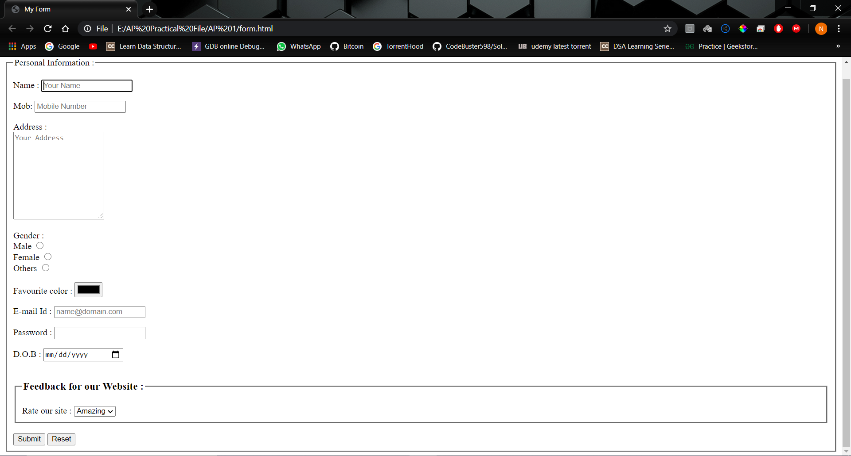

$Write a program for creating HTML Homepage using Bootstrap 4.5$

2

HTML CODE :

<!DOCTYPE html>

<html lang="en">

  <head>

    <meta charset="UTF-8" />

    <meta name="viewport" content="width=device-width, initial-scale=1.0" />

    <script

      src="https://kit.fontawesome.com/ccbd908d58.js"

      crossorigin="anonymous"

    ></script>

    <link

      rel="stylesheet"

      href="https://stackpath.bootstrapcdn.com/bootstrap/4.5.0/css/bootstrap.min.css"

      integrity="sha384-9aIt2nRpC12Uk9gS9baDl411NQApFmC26EwAOH8WgZl5MYYxFfc+NcPb1dKGj7Sk"

      crossorigin="anonymous"

    />

    <link rel="stylesheet" href="./css/style.css" />

    <title>Document</title>

  </head>

  <body>

    <div

      class="navbar navbar-expand-sm bg-dark navbar-dark fixed-top"

      id="main-nav"

    >

      <div class="container">

        <a href="index.html" class="navbar-brand mx-auto">LoopLab</a>

      </div>

    </div>

    <!-- Home -->

    <div id="home-section">

      <div class="dark-overlay">

        <div class="home-inner container">

          <div class="row">

            <div class="col-lg-8 d-none d-lg-block">

              <h1 class="display-4">

                Build <strong>social profiles</strong> and gain revenue

                <strong>profits</strong>

              </h1>

              <div class="d-flex">

                <div class="p-4 align-self-start">

                  <i class="fas fa-check fa-2x"></i>

                </div>

                <div class="p-4 align-self-end">

                  <p>

                    Lorem ipsum dolor sit amet consectetur adipisicing elit.

                    Obcaecati soluta voluptate velit doloremque aperiam omnis?

                  </p>

                </div>

              </div>

              <div class="d-flex">

                <div class="p-4 align-self-start">

                  <i class="fas fa-check fa-2x"></i>

                </div>

                <div class="p-4 align-self-end">

                  <p>

                    Lorem ipsum dolor sit amet consectetur adipisicing elit.

                    Obcaecati soluta voluptate velit doloremque aperiam omnis?

                  </p>

                </div>

              </div>

              <div class="d-flex">

                <div class="p-4 align-self-start">

                  <i class="fas fa-check fa-2x"></i>

                </div>

                <div class="p-4 align-self-end">

                  <p>

                    Lorem ipsum dolor sit amet consectetur adipisicing elit.

                    Obcaecati soluta voluptate velit doloremque aperiam omnis?

                  </p>

                </div>

              </div>

            </div>

            <div class="col-lg-4">

              <div class="card bg-primary text-center card-form">

                <div class="card-body">

                  <h3>Sign Up Today</h3>

                  <p>Please fill up this form to register</p>

                  <form>

                    <div class="form-group">

                      <input

                        type="text"

                        class="form-control form-control-lg"

                        placeholder="Username"

                      />

                    </div>

                    <div class="form-group">

                      <input

                        type="email"

                        class="form-control form-control-lg"

                        placeholder="Email"

                      />

                    </div>

                    <div class="form-group">

                      <input

                        type="password"

                        class="form-control form-control-lg"

                        placeholder="Password"

                      />

                    </div>

                    <div class="form-group">

                      <input

                        type="password"

                        class="form-control form-control-lg"

                        placeholder="Confirm Password"

                      />

                    </div>

                    <input

                      type="submit"

                      value="Submit"

                      class="btn btn-outline-light btn-block"

                    />

                  </form>

                </div>

              </div>

            </div>

          </div>

        </div>

      </div>

    </div>

<script

      src="https://code.jquery.com/jquery-3.5.1.min.js"

      integrity="sha256-9/aliU8dGd2tb6OSsuzixeV4y/faTqgFtohetphbbj0="

      crossorigin="anonymous"

    ></script>

    <script

      src="https://cdn.jsdelivr.net/npm/popper.js@1.16.0/dist/umd/popper.min.js"

      integrity="sha384-Q6E9RHvbIyZFJoft+2mJbHaEWldlvI9IOYy5n3zV9zzTtmI3UksdQRVvoxMfooAo"

      crossorigin="anonymous"

    ></script>

    <script

      src="https://stackpath.bootstrapcdn.com/bootstrap/4.5.0/js/bootstrap.min.js"

      integrity="sha384-OgVRvuATP1z7JjHLkuOU7Xw704+h835Lr+6QL9UvYjZE3Ipu6Tp75j7Bh/kR0JKI"

      crossorigin="anonymous"

    ></script>

  </body>

</html>

CSS CODE :

body {

  background: #333;

  color: #fff;

}

.navbar {

  border-bottom: #008ed6 3px solid;

  opacity: 0.8;

}

#home-section {

  background: url(../img/home.jpg);

  background-attachment: fixed;

  background-repeat: no-repeat;

  background-size: cover;

  height: 100vh;

}

#home-section .dark-overlay {

  position: absolute;

  top: 0;

  left: 0;

  width: 100%;

  height: inherit;

  background: rgba(0, 0, 0, 0.7);

}

#home-section .home-inner {

  margin-top: 150px;

}

#home-section .card-form {

  opacity: 0.8;

}

#home-section .fas {

  color: #008ed6;

  background: #fff;

  padding: 5px;

  border-radius: 5px;

}

OUTPUT :

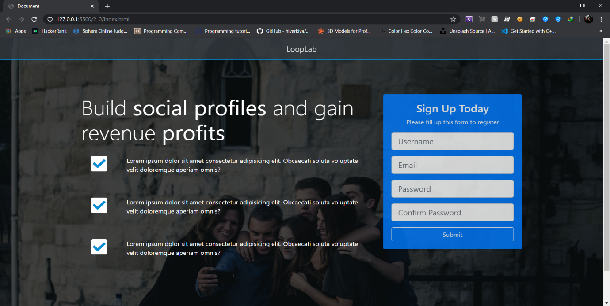

$Write a program to understand working of API using fetch$

3

$$and promises \& handling the response using Async_Await$$

HTML CODE :

<!DOCTYPE html>

<html lang="en">

  <head>

    <meta charset="UTF-8" />

    <meta name="viewport" content="width=device-width, initial-scale=1.0" />

    <link

      rel="stylesheet"

      href="https://bootswatch.com/4/cyborg/bootstrap.min.css"

    />

    <title>Profile Finder | Github</title>

  </head>

  <body>

    <nav class="navbar navbar-expand-sm bg-dark navbar-dark mb-4">

      <div class="container">

        <a href="#" class="navbar-brand">Profile Finder (Github)</a>

      </div>

    </nav>

    <div class="container searchContainer">

      <div class="card border-info text-white search">

        <div class="card-header">

          <h4>Search Github Users</h4>

        </div>

        <div class="card-body">

          <p class="lead">Enter username to fetch profile and repos of user</p>

          <input

            type="text"

            id="UserName"

            class="form-control border border-primary"

            placeholder="Enter Username..."

          />

        </div>

      </div>

      <hr class="bg-white" />

      <div id="profile"></div>

      <h4 class="bg-light text-white border border-info rounded p-2 pl-3 my-3">

        Latest Repos

      </h4>

      <div id="repos" class="border border-success rounded"></div>

    </div>

    <footer

      class="bg-black border-top border-bottom border-white text-white p-3 text-center mt-5 mb-3"

    >

      Profile Finder (Github) &copy; 2020

    </footer>

    <script

      src="https://code.jquery.com/jquery-3.5.1.slim.min.js"

      integrity="sha384-DfXdz2htPH0lsSSs5nCTpuj/zy4C+OGpamoFVy38MVBnE+IbbVYUew+OrCXaRkfj"

      crossorigin="anonymous"

    ></script>

    <script

      src="https://cdn.jsdelivr.net/npm/popper.js@1.16.0/dist/umd/popper.min.js"

      integrity="sha384-Q6E9RHvbIyZFJoft+2mJbHaEWldlvI9IOYy5n3zV9zzTtmI3UksdQRVvoxMfooAo"

      crossorigin="anonymous"

    ></script>

    <script

      src="https://stackpath.bootstrapcdn.com/bootstrap/4.5.0/js/bootstrap.min.js"

      integrity="sha384-OgVRvuATP1z7JjHLkuOU7Xw704+h835Lr+6QL9UvYjZE3Ipu6Tp75j7Bh/kR0JKI"

      crossorigin="anonymous"

    ></script>

    <script src="./github.js"></script>

    <script src="./ui.js"></script>

    <script src="./app.js"></script>

  </body>

</html>

JavaScript CODE ( Fetching data form api [github.js] ) :

class Github {

  constructor() {

    this.client_id = "9df188b7d59bbb573db3";

    this.client_secret = "dc2bc7e6f8b42bbc6a3b99f356c75661366ab6e0";

    this.repos_count = 5;

    this.repos_sort = "created: asc";

  }

  async GetUser(user) {

    const profileResponse = await fetch(

      `https://api.github.com/users/${user}?client_id=${this.client_id}&client_secret=${this.client_secret}`

    );

    const repoResponse = await fetch(

      `https://api.github.com/users/${user}/repos?per_page=${this.repos_count}&sort=${this.repos_sort}&client_id=${this.client_id}&client_secret=${this.client_secret}`

    );

    const profile = await profileResponse.json();

    const repos = await repoResponse.json();

    return {

      profile: profile,

      repos: repos,

    };

  }

}

JavaScript CODE ( Handling the UI [ui.js] ) :

class UI {

  constructor() {

    this.profile = document.getElementById("profile");

  }

  ShowProfile(user) {

    this.ClearAlert();

    this.profile.innerHTML = `

    <div class="card border-success">

    <div class="card-header text-center text-white display-3 font-italic">${user.name}</div>

    <div class="card-body">

      <div class="row">

        <div class="col-md-3">

          <img

            src="${user.avatar_url}"

            alt="profile image"

            class="img-fluid w-100 mb-3 border border-white rounded"

          />

          <a href="${user.html_url}" target="_blank" class="btn btn-block btn-outline-success mb-3"

            >View Profile</a

          >

        </div>

        <div class="col-md-9">

          <div class="mb-4">

            <span class="badge badge-primary mr-3">Public Repos: ${user.public_repos}</span>

            <span class="badge badge-secondary mr-3">Public Gists: ${user.public_gists}</span>

            <span class="badge badge-danger mr-3">Followers: ${user.followers}</span>

            <span class="badge badge-warning mr-3">Following: ${user.following}</span>

          </div>

          <div class="mt-3 border border-success rounded align-self-center">

            <ul class="list-group">

              <li class="list-group-item text-white text-capitalize">

                Company: ${user.company}

              </li>

              <li class="list-group-item bg-success text-light">

                Email: ${user.email}

              </li>

              <li class="list-group-item text-white text-capitalize">Location: ${user.location}</li>

              <li class="list-group-item bg-success text-light">

                Member Since: ${user.created_at}

              </li>

            </ul>

          </div>

        </div>

      </div>

    </div>

  </div>

        `;

  }

  ShowRepos(repos) {

    let output = ``;

    repos.forEach(function (repo) {

      output += `

      <div class="card card-body">

      <div class="row">

        <div class="col-md-6 mt-2">

          <a href="${repo.html_url}" target="_blank" class="text-decoration-none">${repo.name}</a>

        </div>

        <div class="col-md-6 mt-2">

        <span class="badge badge-secondary mr-3">Forks: ${repo.forks}</span>

        <span class="badge badge-danger mr-3">Watchers: ${repo.watchers}</span>

        <span class="badge badge-warning mr-3">Stars: ${repo.startgazers_count}</span>

        </div>

      </div>

    </div>

      `;

    });

    const div = document.getElementById("repos");

    div.innerHTML = output;

  }

  ClearProfile() {

    this.profile.innerHTML = "";

  }

  ClearRepos() {

    document.getElementById("repos").innerHTML = "";

  }

  ShowAlert(message) {

    this.ClearAlert();

    const div = document.createElement("div");

    div.className = "alert alert-danger";

    div.innerHTML = message;

    const container = document.querySelector(".searchContainer");

    const search = document.querySelector(".search");

    container.insertBefore(div, search);

    this.ClearProfile();

    this.ClearRepos();

  }

  ClearAlert() {

    const currentAlert = document.querySelector(".alert");

    if (currentAlert != null) {

      currentAlert.remove();

    }

  }

}

JavaScript CODE ( Handling the app [app.js] ) :

const UserName = document.getElementById("UserName");

const github = new Github();

const ui = new UI();

UserName.addEventListener("keyup", ShowContent);

function ShowContent(e) {

  const username = e.target.value;

  if (username !== "") {

    github

      .GetUser(username)

      .then((data) => {

        if (data.profile.message === "Not Found") {

          ui.ShowAlert("USER NOT FOUND!!!");

        } else {

          ui.ShowProfile(data.profile);

          ui.ShowRepos(data.repos);

        }

      })

      .catch((err) => {

        console.log(err);

      });

  } else {

    ui.ClearProfile();

    ui.ClearAlert();

    ui.ClearRepos();

  }

}

OUTPUT (First look ) :

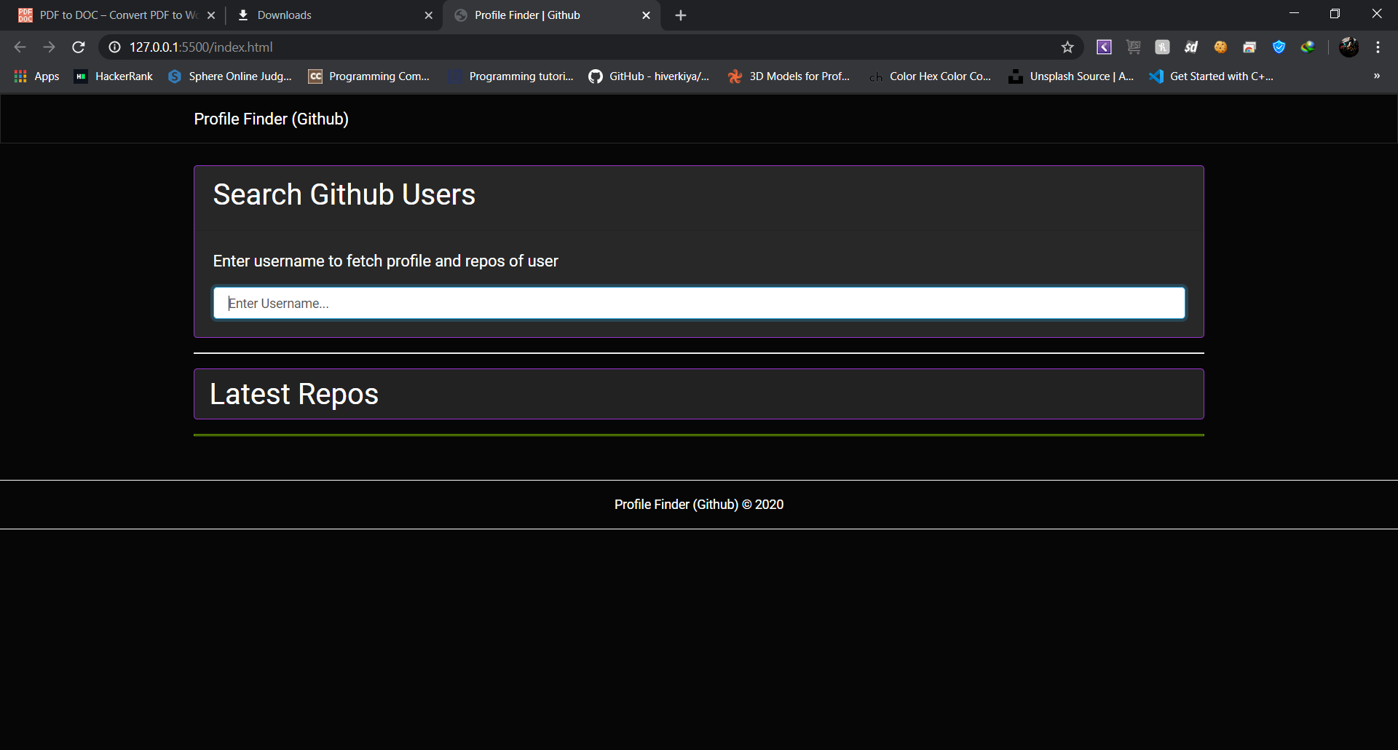

OUTPUT (Entering wrong username // Alert ) :

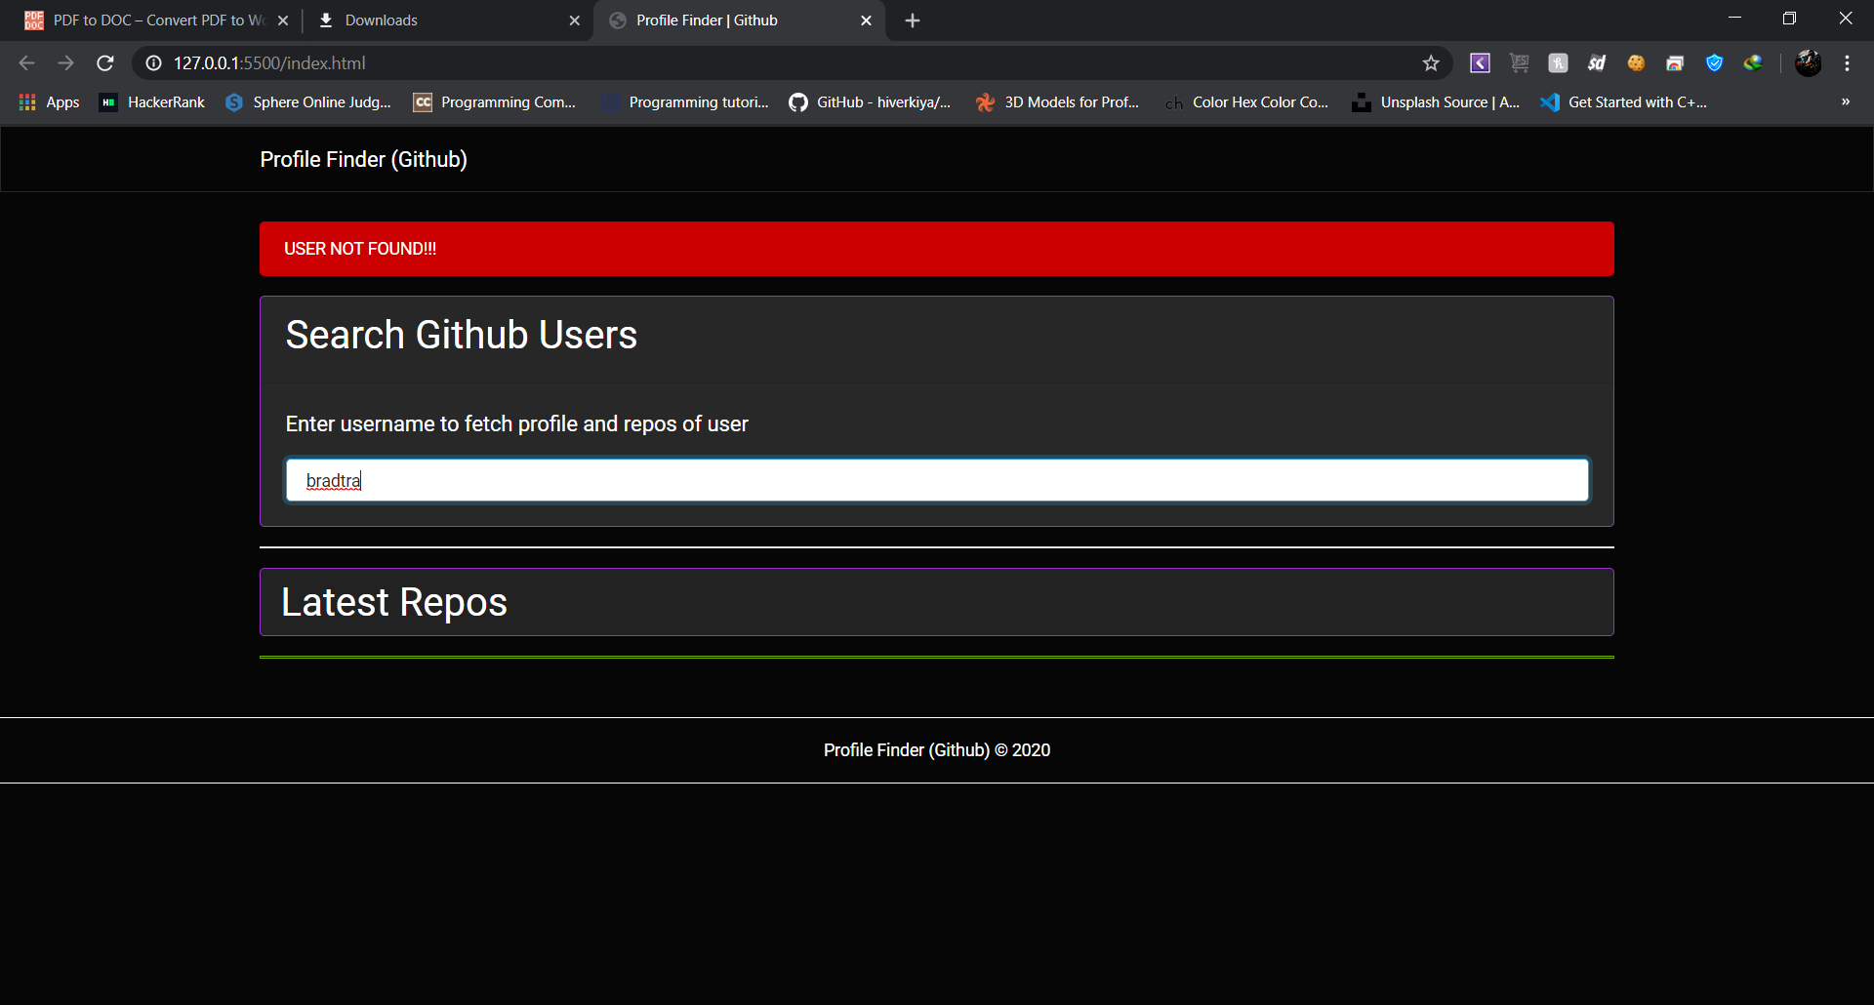OUTPUT (User Profile ) :

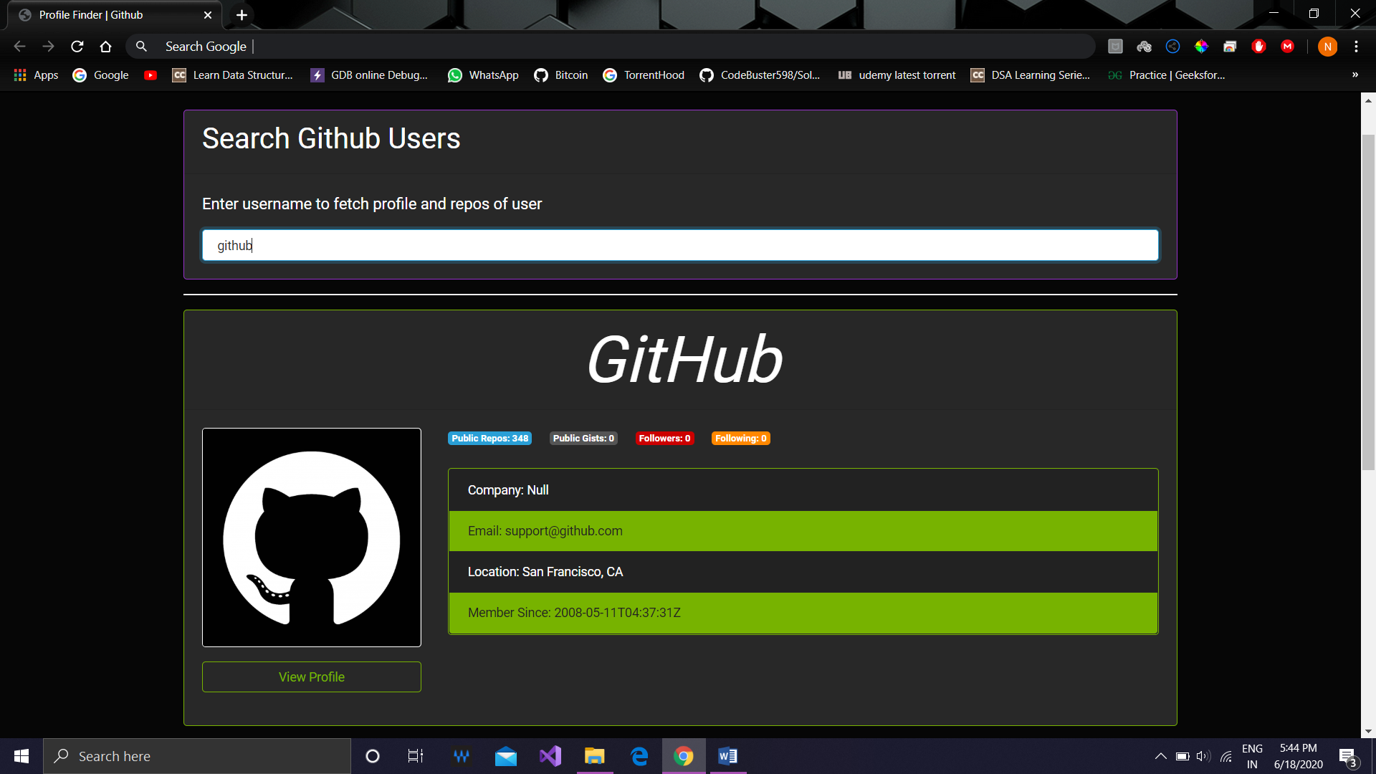

OUTPUT (User latest 5 repos ) :

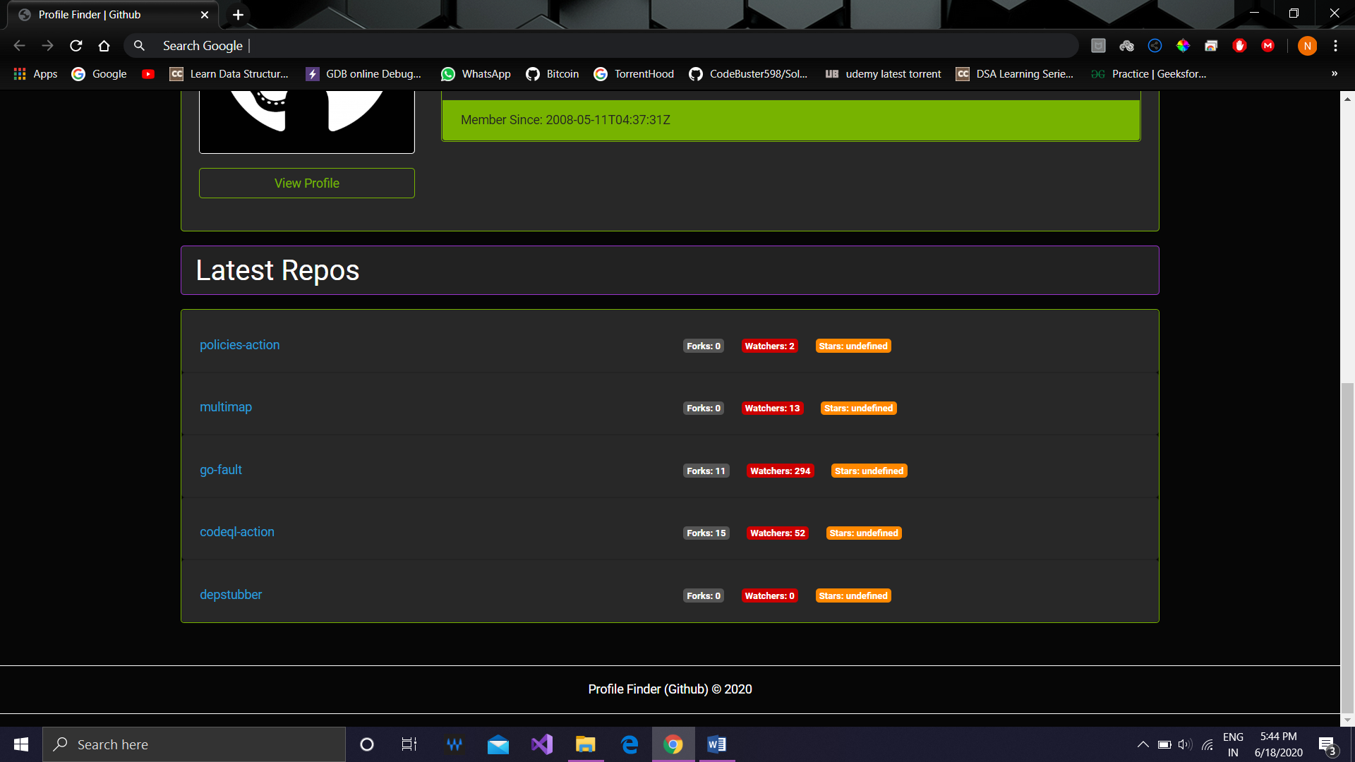

$Setting up and Configuration of apache and mysql server$

4

$$using XAMPP$$

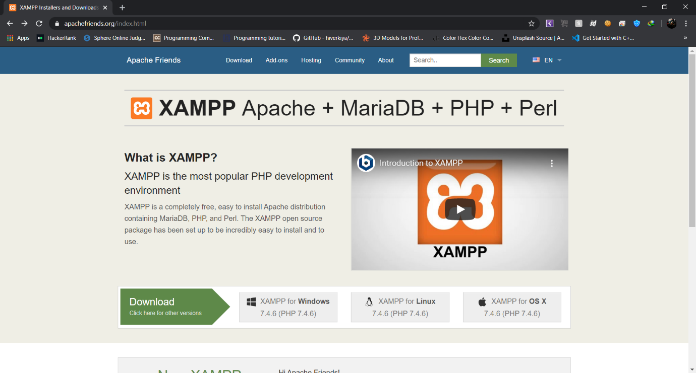Downloading :

Installing :

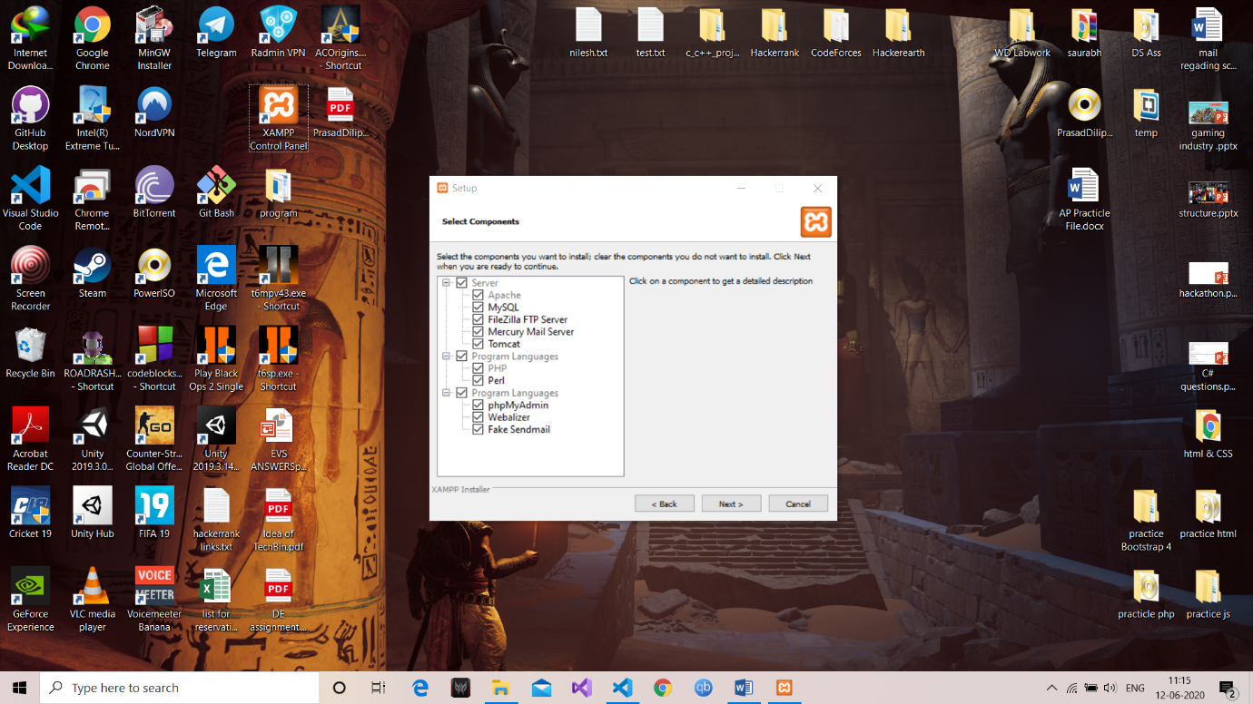

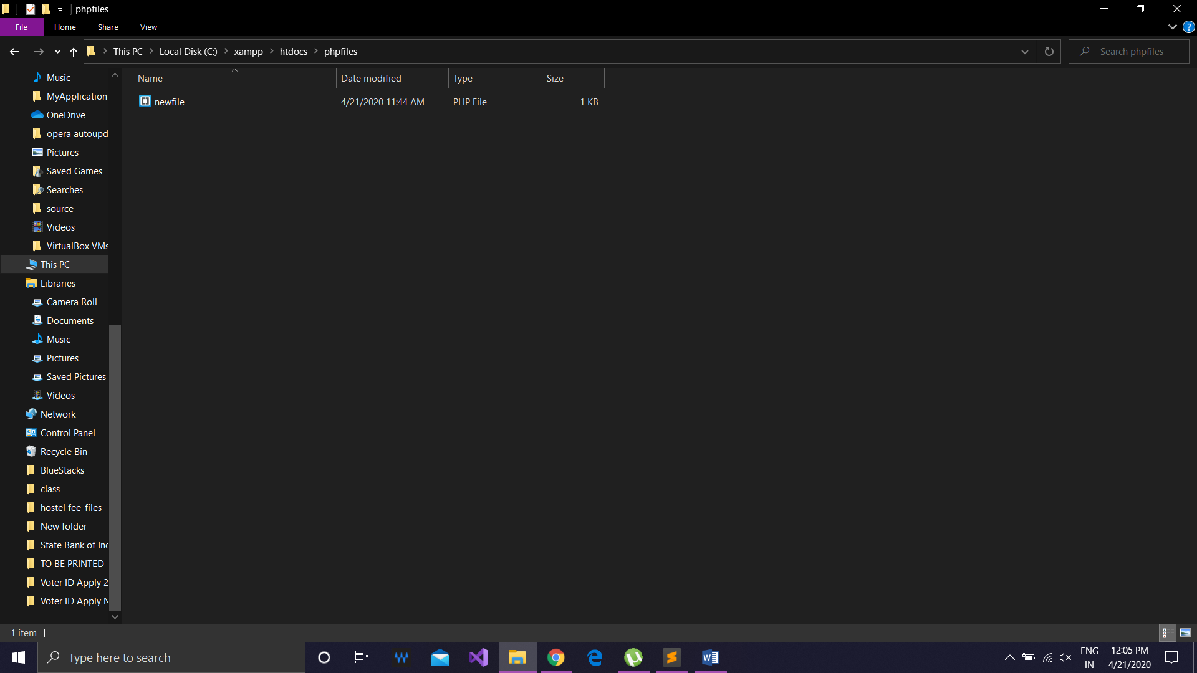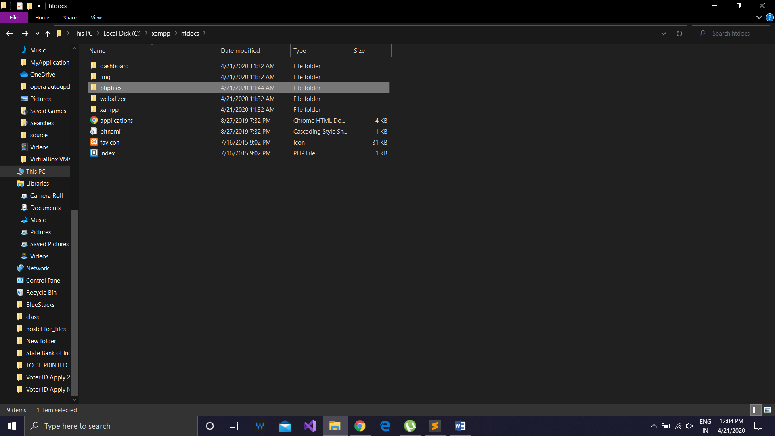

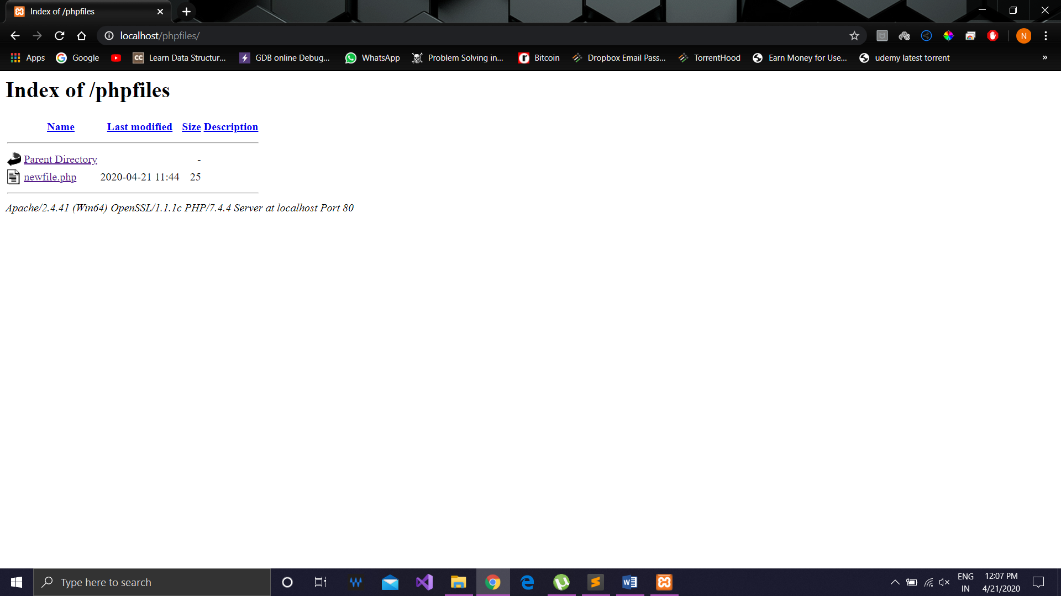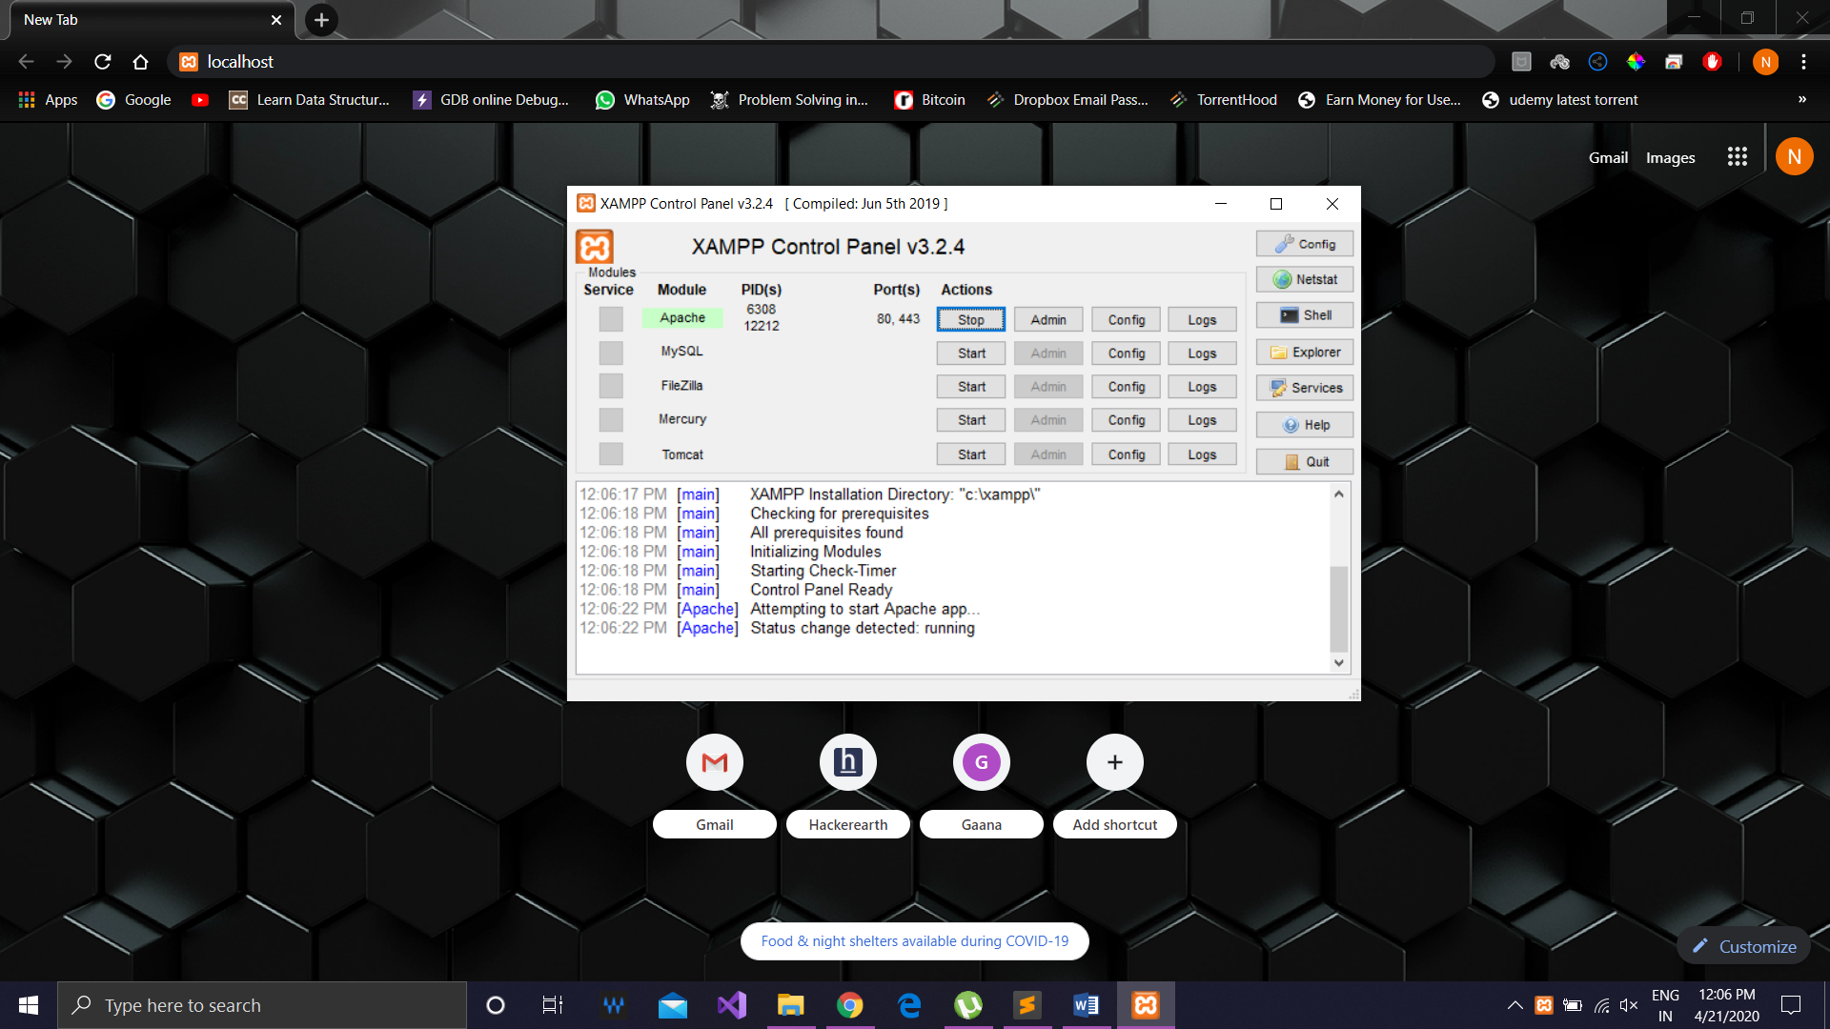

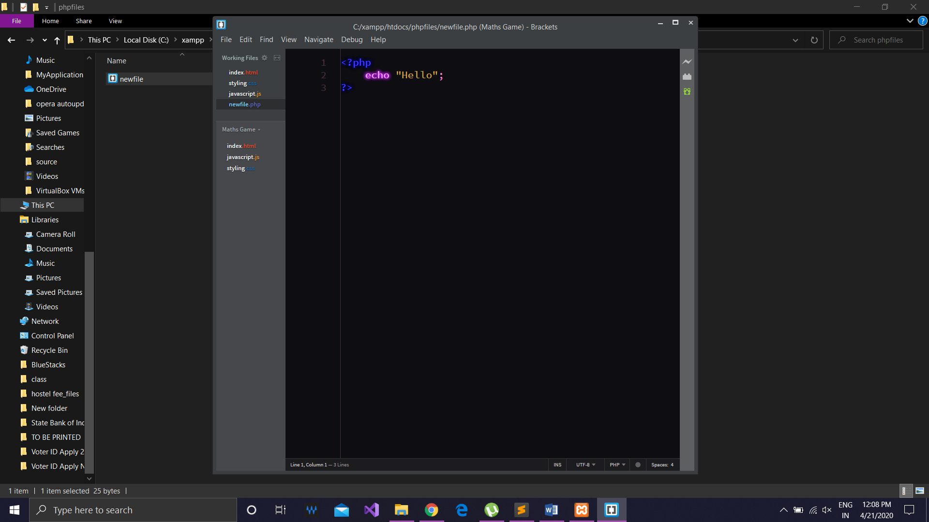PHP CODE (newfile.php) :

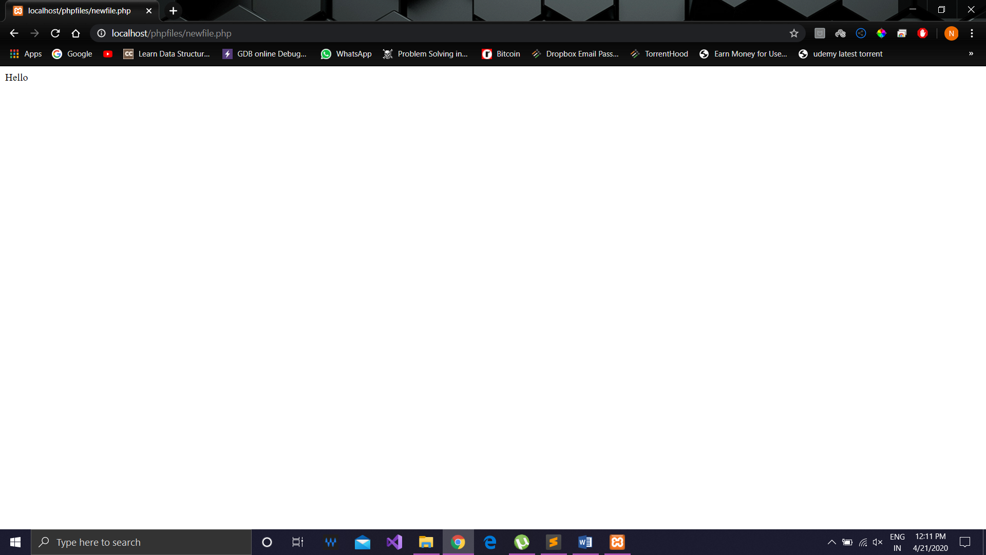OUTPUT :

$Write a program to understand the XMLHttp request to$

5

$$fetch the data$$

HTML CODE :

<!DOCTYPE html>

<html lang="en">

<head>

    <meta charset="UTF-8">

    <meta name="viewport" content="width=device-width, initial-scale=1.0">

    <title>Http Requests</title>

</head>

<body>

    <h1>Learning HTTP Requests</h1>

    <script src="./http_requests.js"></script>

    <script src="./app.js"></script>

</body>

</html>

JavaScript HTTP Request Function Prototypes CODE :

function httprequests(){

    this.http = new XMLHttpRequest();

}

//GET Request

httprequests.prototype.get = function (url, callback) {

    this.http.open("GET", url, true);

    let self = this;

    this.http.onload = function () {

        if (self.http.status === 200) {

            callback(null, self.http.responseText);

        }

        else {

            callback("Error : " + self.http.status);

        }

    }

    this.http.send();

}

//POST Request

httprequests.prototype.post = function (url, data, callback) {

    this.http.open("POST", url, true);

    this.http.setRequestHeader("Content-type", "application/json");

    let self = this;

    this.http.onload = function () {

        callback(null, self.http.responseText);

    }

    this.http.send(JSON.stringify(data));

}

//PUT Request

httprequests.prototype.put = function (url, data, callback) {

    this.http.open("PUT", url, true);

    this.http.setRequestHeader("Content-type", "application/json");

    let self = this;

    this.http.onload = function () {

        callback(null, self.http.responseText);

    }

    this.http.send(JSON.stringify(data));

}

//DELETE Request

httprequests.prototype.delete = function (url, callback) {

    this.http.open("DELETE", url, true);

    let self = this;

    this.http.onload = function () {

        if (self.http.status === 200) {

            callback(null, "Delete Successfull");

        }

        else {

            callback("Error : " + self.http.status);

        }

    }

    this.http.send();

}

JavaScript app CODE (GET) :

const myobj = new httprequests();

//for get

myobj.get("https://jsonplaceholder.typicode.com/posts", function (err,posts) {

    if (err) {

        console.log(err);

    }

    else {

        console.log(posts);

    }

});

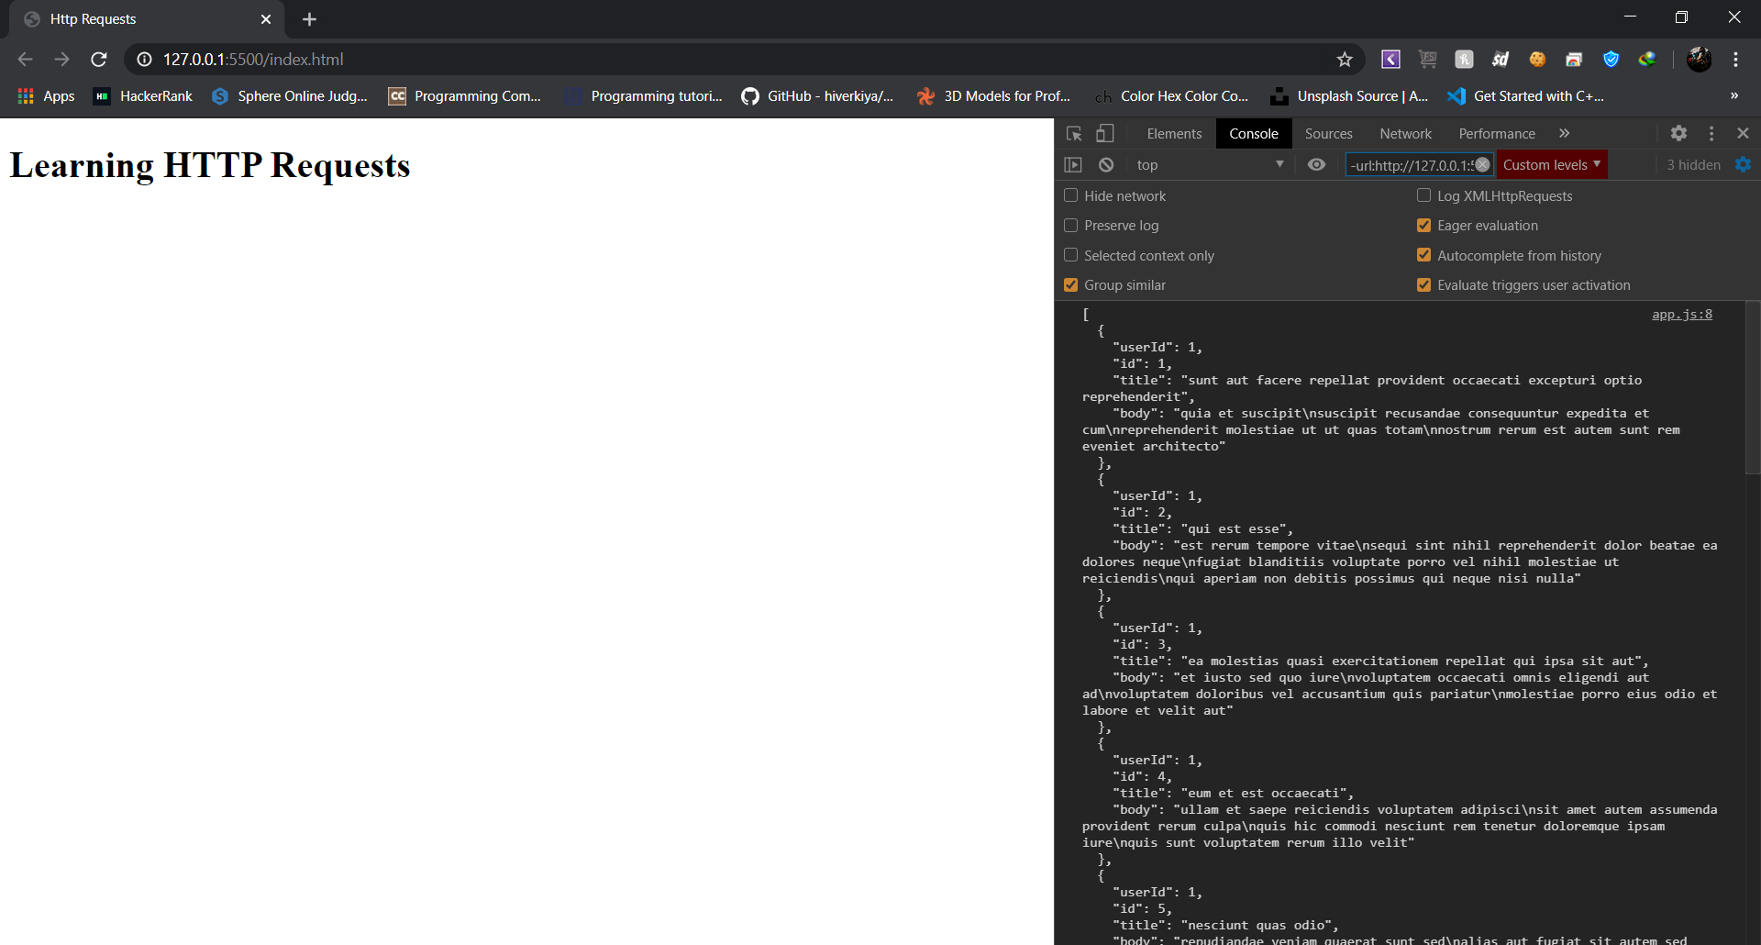OUTPUT (GET) :

JavaScript app CODE (Single GET) :

const myobj = new httprequests();

//for single get

myobj.get("https://jsonplaceholder.typicode.com/posts/24", function (

  err,

  post

) {

  if (err) {

    console.log(err);

  } else {

    console.log(post);

  }

});

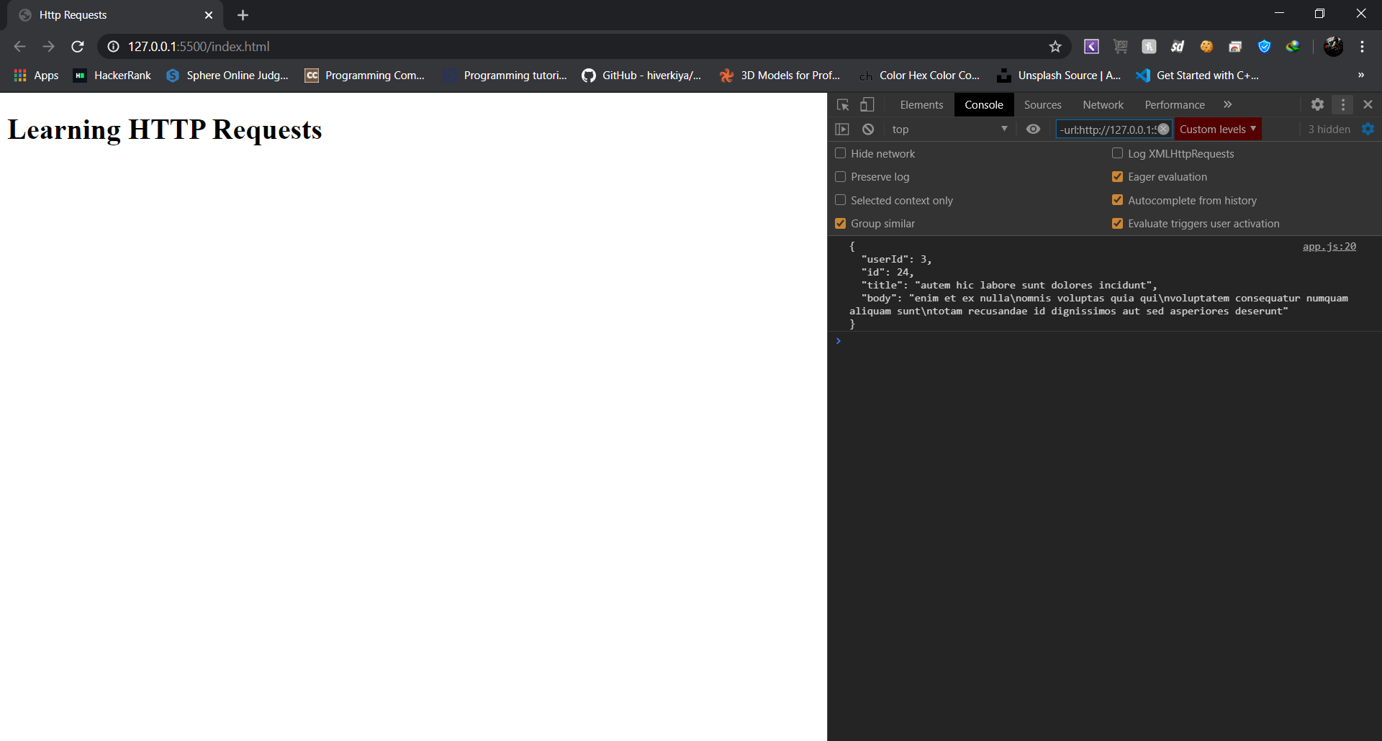OUTPUT (Single GET) :

JavaScript app CODE (Post) :

const data = {

  title: "Hello World",

  body: "gfcg vhgvgjh jhgkhg jgh",

};

//for post

myobj.post("https://jsonplaceholder.typicode.com/posts", data, function (

  err,

  post

) {

  if (err) {

    console.log(err);

  } else {

    console.log(post);

  }

});

JavaScript app CODE (Put) :

const data = {

  title: "Hello World",

  body: "hfjh ygyfy uyf yu yuf ",

};

//for update(put)

myobj.put("https://jsonplaceholder.typicode.com/posts/1", data, function (err,post) {

    if (err) {

        console.log(err);

    }

    else {

        console.log(post);

    }

});

JavaScript app CODE (Delete) :

//for delete

myobj.delete("https://jsonplaceholder.typicode.com/posts/1", function (

  err,

  response

) {

  if (err) {

    console.log(err);

  } else {

    console.log(response);

  }

});

OUTPUT (Delete) :

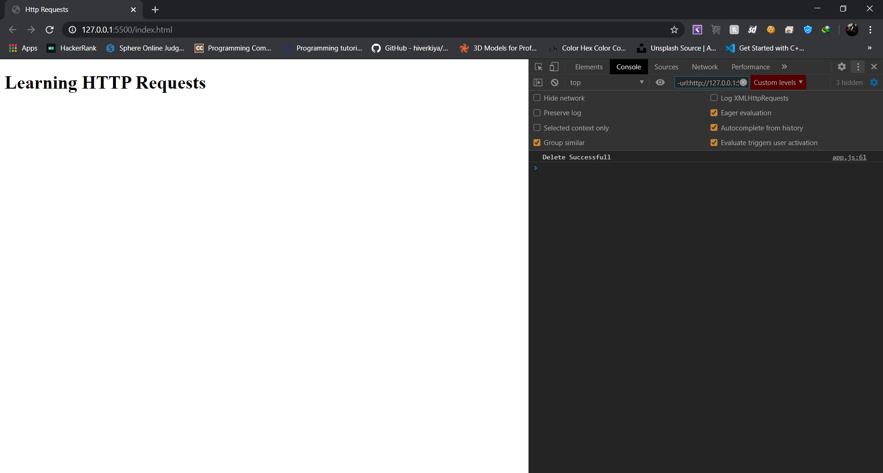

$Write a program for creating Website Using PHP$

6

$$(Simple Registration webpage)$$

HTML Code :

<!DOCTYPE html>

<html lang="en">

  <head>

    <meta charset="UTF-8">

    <meta name="viewport" content="width=device-width, initial-scale=1.0">

    <title>Registration Page</title>

    <link rel="stylesheet" href="style.css">

    <style>

        label {

            visibility: hidden;

        }

    </style>

</head>

<body>

   <script src="app.js"></script>

    <div class="container">

        <div class="container__left">

            &nbsp;

        </div>

        <div class="form-wrap">

        <h1 class="heading margin-bottom">Registration Info</h1>

        <form action="form.php" method="POST" onsubmit="return validate()">

          <div class="form-group">

            <label for="first-name" id="firstName">Invalid</label>

            <input type="text" name="firstName" class="form-input" id="first-name" placeholder="First Name">

          </div>

          <div class="form-group">

            <label for="last-name" id="lastName">Invalid</label>

            <input type="text" name="lastName" class="form-input" id="last-name" placeholder="Last Name">

          </div>

          <div class="form-group">

            <label for="email">Invalid</label>

            <input type="email" name="email" class="form-input" id="email" placeholder="Email" >

          </div>

          <div class="form-group margin-bottom">

            <label for="password">Invalid</label>

            <input type="password" name="password" class="form-input" id="password" placeholder="Password">

          </div>

          <button type="submit" name ="submit" class="btn">Sign Up</button>

        </form>

      </div>

    </div>

</body>

CSS Code :

*,

*::after,

*::before {

    box-sizing: border-box;

    margin: 0;

    padding: 0;

}

body {

    background-color: #FB4250;

}

.container {

    width: 60%;

    height: 550px;

    margin: 5.5% auto;

    background-color: #fff;

    border-radius: 8px;

    overflow: hidden;

}

.container__left {

    background-image: url(fruit.JPG);

    background-repeat: no-repeat;

    width: 28%;

    height: 100%;

    float: left;

}

.form-wrap {

    width: 72%;

    float: right;

    height: 100%;

    padding: 4rem;

    background-color: #F3EEEE;

}

.heading {

    text-transform: uppercase;

    color: #999;

    font-family: sans-serif;

}

.form-group {

    font-size: 20px;

    padding: 10px 0;

}

.form-input {

    border: none;

    background-color: #F3EEEE;

    border-bottom: 1px solid #777;

    padding: .9rem 0;

    width: 80%;

}

.form-input:focus {

    outline: none;

    border-bottom: 1px solid #55c57a;

}

.btn {

    padding: 8px;

    background-color: #55c57a;

    color: #fff;

    box-shadow: 0 3px rgba(0,0,0,.15);

}

.margin-bottom {

    margin-bottom: 30px;

}

PHP Form Code :

<?php

function ShowAlert($message,$info)

{

    echo "<h1>$message</h1>" . "<br>";

    echo "<h3>$info</h3>";

}

if(isset($_POST["submit"]))

{

    $firstName = $_POST["firstName"];

    $lastName = $_POST["lastName"];

    $email = $_POST["email"];

    $password = $_POST["password"];

    $connection = mysqli_connect("localhost","Vecto","guptanilesh2000","vc");

    if($connection)

    {

        $query = "INSERT INTO users(FirstName,LastName,Email,Password) ";

        $query .= "VALUES ('$firstName','$lastName','$email','$password')";

        $result = mysqli_query($connection , $query);

        if($result)

        {

            ShowAlert("User Successfully registered into database","Welcome to our Family");

        }

        else

        {

            ShowAlert("Something Went Wrong With database","Debugging error: " . mysqli_error($connection));

        }

    }

    else

    {

        ShowAlert("Something Went Wrong With Connection","Debugging error: " . mysqli_connect_error());

    }

}

?>

OUTPUT (Page) :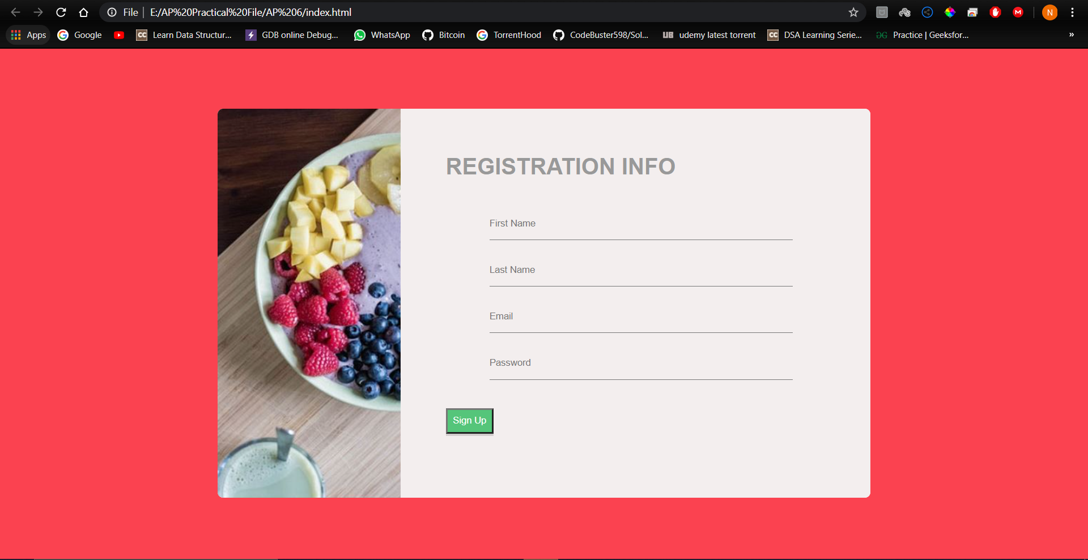

$Write a program to Understand The JavaScript$

7

$$\left(Loan Calculator\right) using Bootstrap$$

1. DOM (Document Object Model)

2. Usage of ES6 standards (let, const instead of var)

3. And small concepts like

I. Event Handling

II. Alert Message

HTML CODE :

<!DOCTYPE html>

<html lang="en">

  <head>

    <!-- Required meta tags -->

    <meta charset="utf-8" />

    <meta

      name="viewport"

      content="width=device-width, initial-scale=1, shrink-to-fit=no"

    />

    <!-- Bootstrap CSS -->

    <link

      rel="stylesheet"

      href="https://stackpath.bootstrapcdn.com/bootstrap/4.5.0/css/bootstrap.min.css"

      integrity="sha384-9aIt2nRpC12Uk9gS9baDl411NQApFmC26EwAOH8WgZl5MYYxFfc+NcPb1dKGj7Sk"

      crossorigin="anonymous"

    />

    <title>Loan Calculator</title>

  </head>

  <body class="bg-dark">

    <div class="container">

      <div class="row">

        <div class="col-md-6 mx-auto">

          <div class="card card-body text-center mt-5">

            <h1 class="heading display-5 pb-3">Loan Calculator</h1>

            <form id="loan-form">

              <div class="form-group">

                <div class="input-group">

                  <span class="input-group-text">$</span>

                  <input

                    type="text"

                    class="form-control"

                    id="amount"

                    placeholder="Loan Amount"

                  />

                </div>

              </div>

              <div class="form-group">

                <div class="input-group">

                  <span class="input-group-text">%</span>

                  <input

                    type="text"

                    class="form-control"

                    id="interest"

                    placeholder="Interest"

                  />

                </div>

              </div>

              <div class="form-group">

                <div class="input-group">

                  <input

                    type="text"

                    class="form-control"

                    id="years"

                    placeholder="Years to Repay"

                  />

                </div>

              </div>

              <div class="form-group">

                <input

                  type="submit"

                  value="Calculate"

                  class="btn btn-dark btn-block"

                />

              </div>

            </form>

            <!-- LOADER HERE -->

            <div id="loading">

              <img src="img/loading.gif" />

            </div>

            <!-- RESULTS -->

            <div id="results" class="pt-4">

              <h5 class="heading display-5 pb-3">Results</h5>

              <div class="form-group">

                <div class="input-group">

                  <span class="input-group-text">Monthly Payment</span>

                  <input

                    type="text"

                    class="form-control"

                    id="monthly-payment"

                    disabled

                  />

                </div>

              </div>

              <div class="form-group">

                <div class="input-group">

                  <span class="input-group-text">Total Payment</span>

                  <input

                    type="text"

                    class="form-control"

                    id="total-payment"

                    disabled

                  />

                </div>

              </div>

              <div class="form-group">

                <div class="input-group">

                  <span class="input-group-text">Total Interest</span>

                  <input

                    type="text"

                    class="form-control"

                    id="total-interest"

                    disabled

                  />

                </div>

              </div>

            </div>

          </div>

        </div>

      </div>

    </div>

    <!-- Optional JavaScript -->

    <!-- jQuery first, then Popper.js, then Bootstrap JS -->

    <script

      src="https://code.jquery.com/jquery-3.5.1.slim.min.js"

      integrity="sha384-DfXdz2htPH0lsSSs5nCTpuj/zy4C+OGpamoFVy38MVBnE+IbbVYUew+OrCXaRkfj"

      crossorigin="anonymous"

    ></script>

    <script

      src="https://cdn.jsdelivr.net/npm/popper.js@1.16.0/dist/umd/popper.min.js"

      integrity="sha384-Q6E9RHvbIyZFJoft+2mJbHaEWldlvI9IOYy5n3zV9zzTtmI3UksdQRVvoxMfooAo"

      crossorigin="anonymous"

    ></script>

    <script

      src="https://stackpath.bootstrapcdn.com/bootstrap/4.5.0/js/bootstrap.min.js"

      integrity="sha384-OgVRvuATP1z7JjHLkuOU7Xw704+h835Lr+6QL9UvYjZE3Ipu6Tp75j7Bh/kR0JKI"

      crossorigin="anonymous"

    ></script>

    <script src="app.js"></script>

  </body>

</html>

JavaScript CODE :

document.getElementById('results').style.display = 'none';

document.getElementById('loading').style.display = 'none';

//Listening to Submit button

document.querySelector('#loan-form').addEventListener('submit',function(event) {

    //Hide the results

    document.getElementById('results').style.display = 'none';

    //Show Loader

    document.getElementById('loading').style.display = 'block';

    setTimeout(calculation, 2000);

    event.preventDefault();

});

//Calculating Results

function calculation() {

    //UI Variables

    const amount = document.getElementById('amount');

    const interest = document.getElementById('interest');

    const years = document.getElementById('years');

    const monthlyPayment = document.getElementById('monthly-payment');

    const totalPayment = document.getElementById('total-payment');

    const totalInterest = document.getElementById('total-interest');

    const principal = parseFloat(amount.value);

    const calculatedInterest = parseFloat(interest.value) / 100 / 12;

    const calculatedPayments = parseFloat(years.value) * 12;

    //Compute Monthly Payments

    const x = Math.pow(1 + calculatedInterest, calculatedPayments);

    const monthly = (principal*x*calculatedInterest)/(x-1);

    //Hide Loader

    document.getElementById('loading').style.display = 'none';

    if(isFinite(monthly)) {

        monthlyPayment.value = '$ ' + monthly.toFixed(2);

        totalPayment.value = '$ ' +  (monthly * calculatedPayments).toFixed(2);

        totalInterest.value = '$ ' +  ((monthly * calculatedPayments) - principal).toFixed(2);

        //Show the results

        document.getElementById('results').style.display = 'block';

    } else {

        showError('Please check the numbers');

    }

}

//Error function

function showError(error) {

    //Create a div

    errorDiv = document.createElement('div');

    const card = document.querySelector('.card');

    const heading = document.querySelector('.heading');

    //Adding classes to our div

    errorDiv.className = 'alert alert-danger';

    //Create text-node and append it to the div

    errorDiv.appendChild(document.createTextNode(error));

    //Insert it before heading

    card.insertBefore(errorDiv, heading);

    //Clear error after 3seconds

    setTimeout(clearError, 3000);

}

//Clear Error

function clearError() {

    document.querySelector('.alert').remove();

}

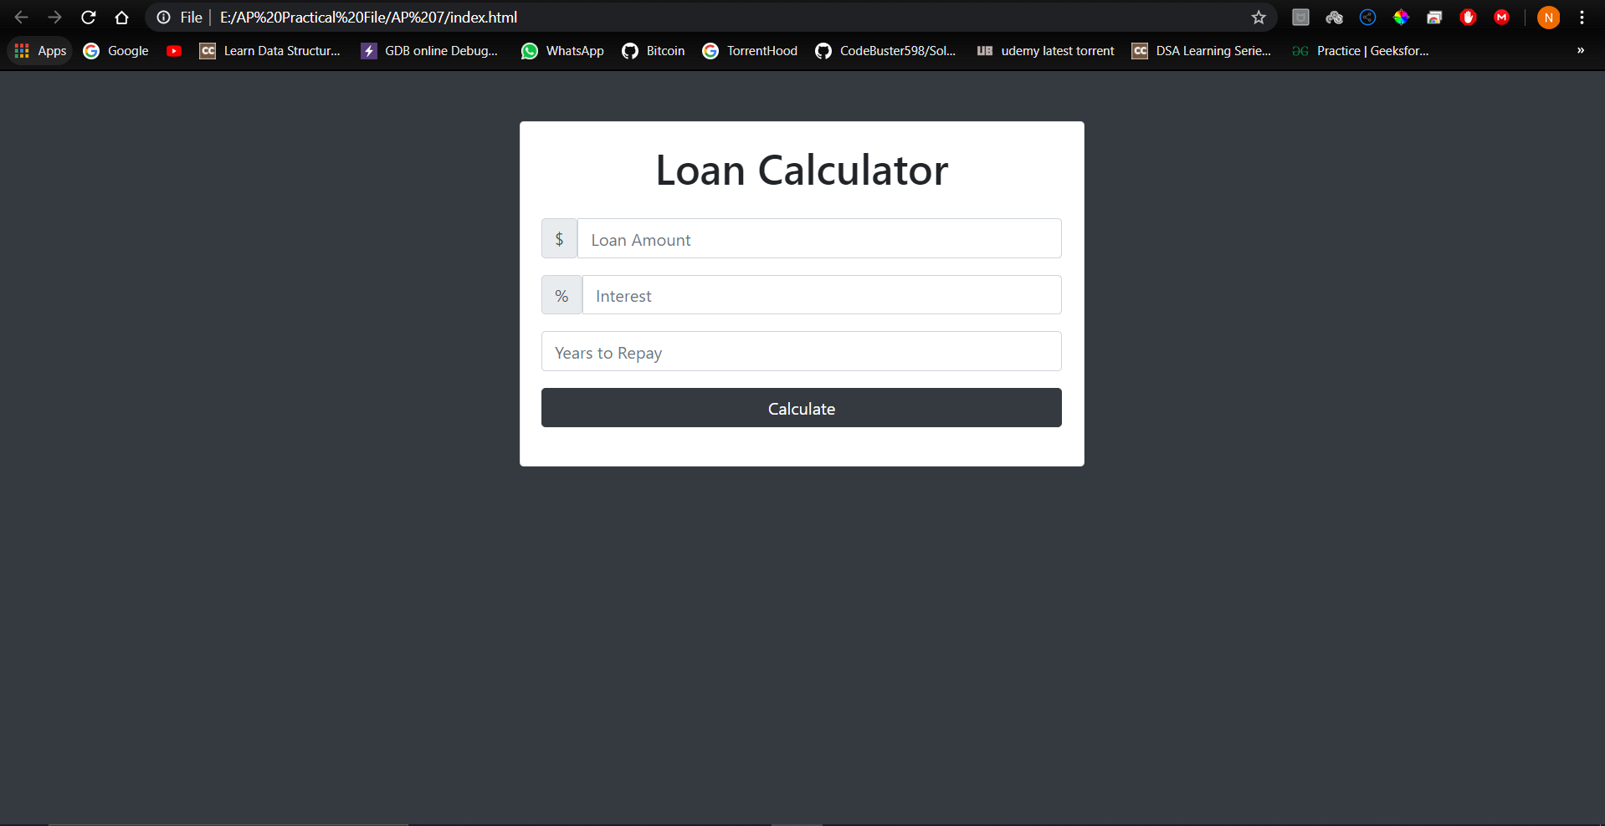OUTPUT (First Look) :

OUTPUT (Calculating Results) :

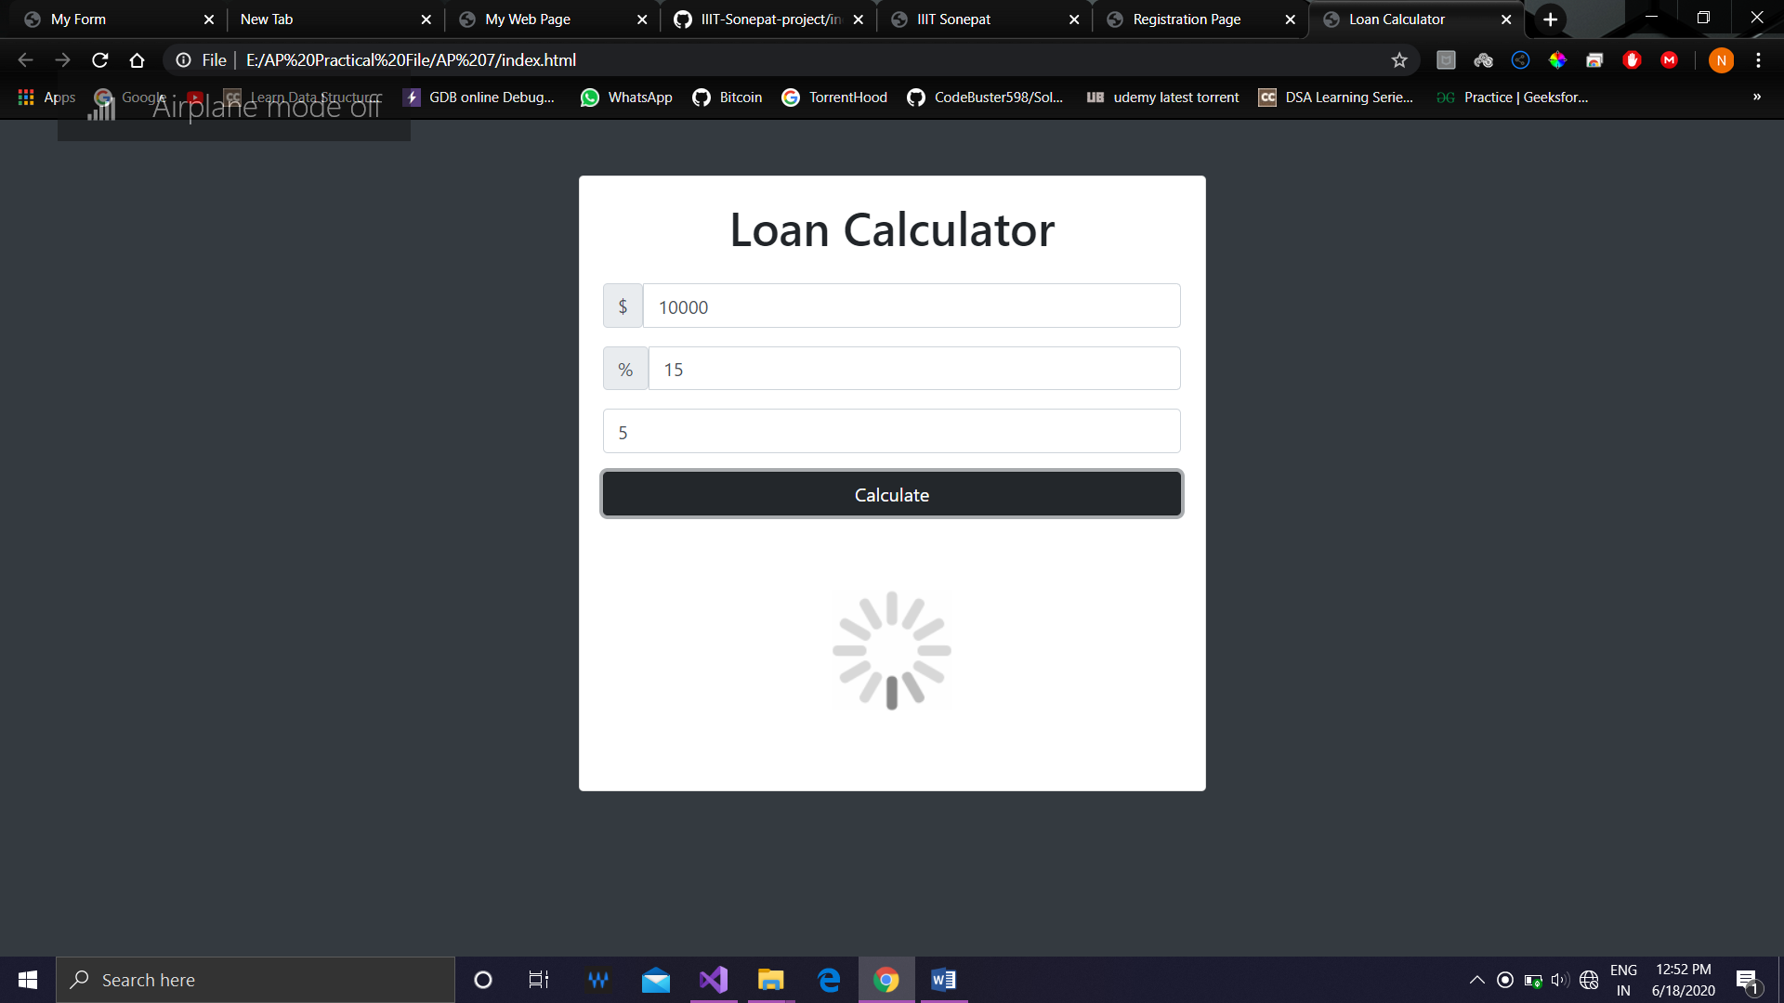

OUTPUT (Results ) :

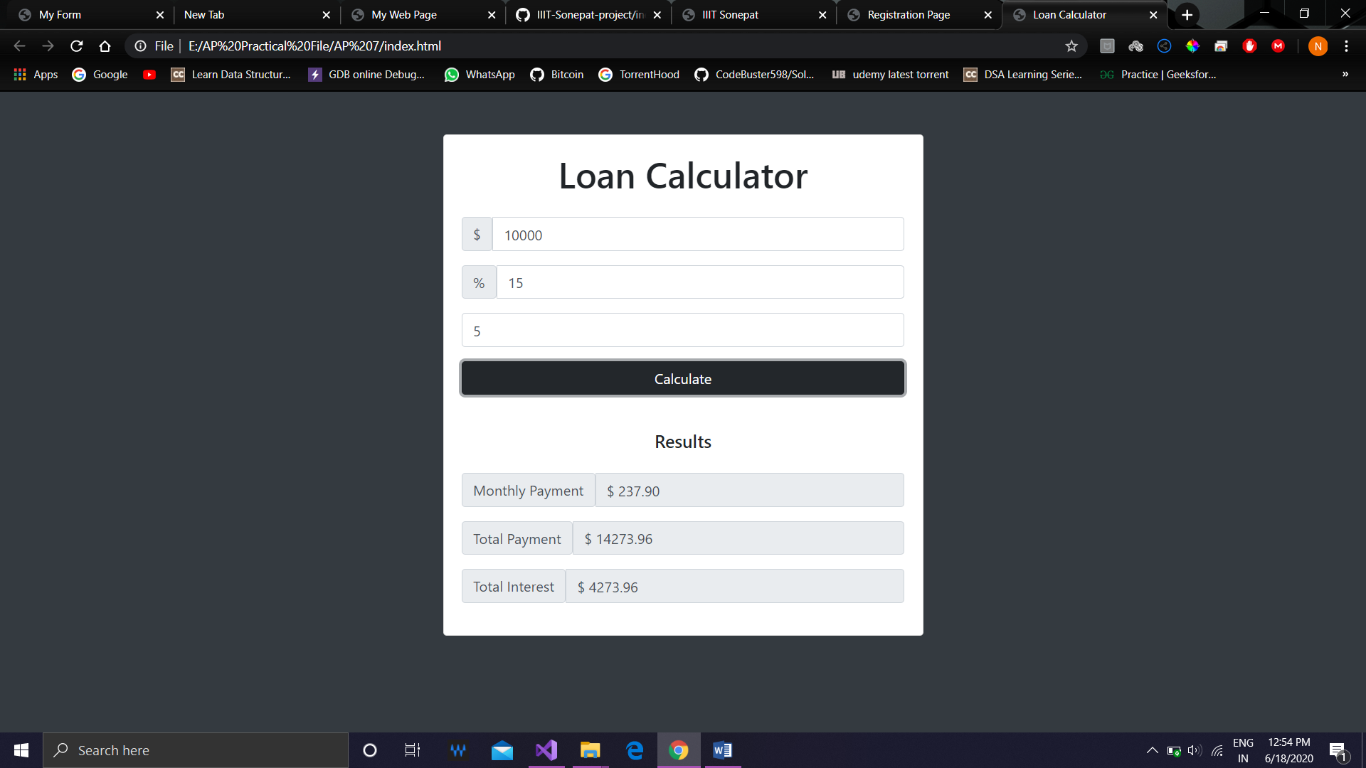

OUTPUT (When can’t calculate the results) :

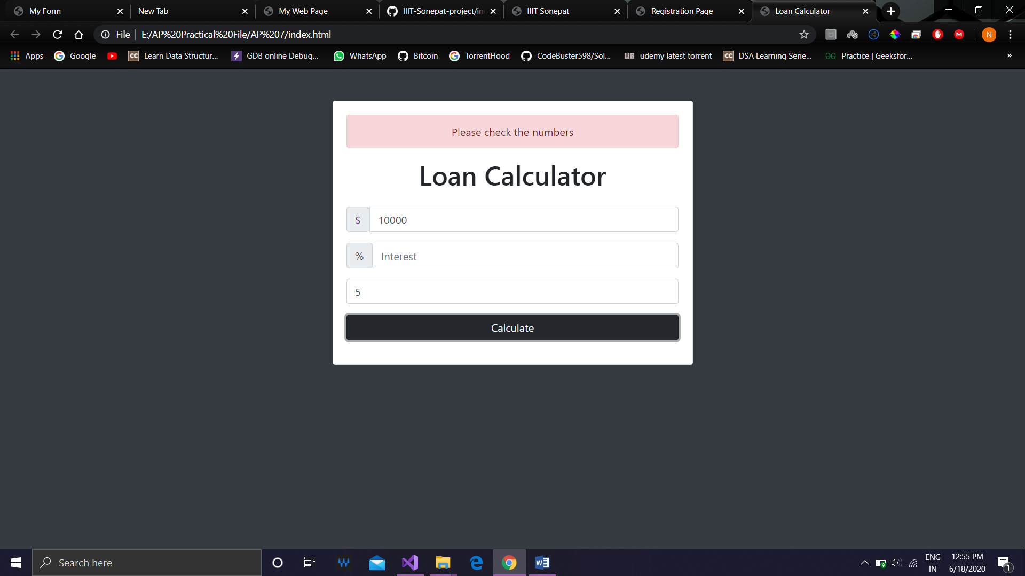

8

1. SQL Database

2. Form Validation in Javascript

3. Fetching data from the form and putting it in the database

HTML CODE (index.html) :

<!DOCTYPE html>

<html lang="en">

  <head>

    <meta charset="UTF-8" />

    <meta name="viewport" content="width=device-width, initial-scale=1.0" />

    <title>Registration Page</title>

    <link rel="stylesheet" href="style.css" />

    <style>

      label {

        visibility: hidden;

      }

    </style>

  </head>

  <body>

    <script src="app.js"></script>

    <div class="container">

      <div class="container__left">

        &nbsp;

      </div>

      <div class="form-wrap">

        <h1 class="heading margin-bottom">Registration Info</h1>

        <form action="form.php" method="POST" onsubmit="return validate()">

          <div class="form-group">

            <label for="first-name" id="firstName">Invalid</label>

            <input

              type="text"

              name="firstName"

              class="form-input"

              id="first-name"

              placeholder="First Name"

            />

          </div>

          <div class="form-group">

            <label for="last-name" id="lastName">Invalid</label>

            <input

              type="text"

              name="lastName"

              class="form-input"

              id="last-name"

              placeholder="Last Name"

            />

          </div>

          <div class="form-group">

            <label for="email">Invalid</label>

            <input

              type="email"

              name="email"

              class="form-input"

              id="email"

              placeholder="Email"

            />

          </div>

          <div class="form-group margin-bottom">

            <label for="password">Invalid</label>

            <input

              type="password"

              name="password"

              class="form-input"

              id="password"

              placeholder="Password"

            />

          </div>

          <button type="submit" name="submit" class="btn">Sign Up</button>

        </form>

      </div>

    </div>

  </body>

</html>

CSS Code :

*,

*::after,

*::before {

  box-sizing: border-box;

  margin: 0;

  padding: 0;

}

body {

  background-color: #fb4250;

}

.container {

  width: 60%;

  height: 550px;

  margin: 5.5% auto;

  background-color: #fff;

  border-radius: 8px;

  overflow: hidden;

}

.container__left {

  background-image: url(fruit.JPG);

  background-repeat: no-repeat;

  width: 28%;

  height: 100%;

  float: left;

}

.form-wrap {

  width: 72%;

  float: right;

  height: 100%;

  padding: 4rem;

  background-color: #f3eeee;

}

.heading {

  text-transform: uppercase;

  color: #999;

  font-family: sans-serif;

}

.form-group {

  font-size: 20px;

  padding: 10px 0;

}

.form-input {

  border: none;

  background-color: #f3eeee;

  border-bottom: 1px solid #777;

  padding: 0.9rem 0;

  width: 80%;

}

.form-input:focus {

  outline: none;

  border-bottom: 1px solid #55c57a;

}

.btn {

  padding: 8px;

  background-color: #55c57a;

  color: #fff;

  box-shadow: 0 3px rgba(0, 0, 0, 0.15);

}

.margin-bottom {

  margin-bottom: 30px;

}

PHP Form Code :

<?php

function ShowAlert($message,$info)

{

    echo "<h1>$message</h1>" . "<br>";

    echo "<h3>$info</h3>";

}

if(isset($_POST["submit"]))

{

    $firstName = $_POST["firstName"];

    $lastName = $_POST["lastName"];

    $email = $_POST["email"];

    $password = $_POST["password"];

    $connection = mysqli_connect("localhost","Vecto","guptanilesh2000","vc");

    if($connection)

    {

        $query = "INSERT INTO users(FirstName,LastName,Email,Password) ";

        $query .= "VALUES ('$firstName','$lastName','$email','$password')";

        $result = mysqli_query($connection , $query);

        if($result)

        {

            ShowAlert("User Successfully registered into database","Welcome to our Family");

        }

        else

        {

            ShowAlert("Something Went Wrong With database","Debugging error: " . mysqli_error($connection));

        }

    }

    else

    {

        ShowAlert("Something Went Wrong With Connection","Debugging error: " . mysqli_connect_error());

    }

}

?>

JAVASCRIPT CODE :

function validate() {

  const firstName = document.getElementById("first-name");

  const lastName = document.getElementById("last-name");

  const email = document.getElementById("email");

  const password = document.getElementById("password");

  const simpleEmailRegex = /\S+@\S+\.\S+/;

  if (firstName.value.trim() == "") {

    firstName.style.borderBottom = "solid 1px red";

    alert("Blank First name");

    console.log("Invalid");

    return false;

  } else if (lastName.value.trim() == "") {

    firstName.style.borderBottom = "solid 1px #55c57a";

    lastName.style.borderBottom = "solid 1px red";

    alert("Blank Last name");

    return false;

  } else if (email.value.trim() == "" || !simpleEmailRegex.test(email.value)) {

    firstName.style.borderBottom = "solid 1px #55c57a";

    lastName.style.borderBottom = "solid 1px #55c57a";

    email.style.borderBottom = "solid 1px red";

    alert("Invalid Email");

    return false;

  } else if (password.value.length < 8) {

    firstName.style.borderBottom = "solid 1px #55c57a";

    lastName.style.borderBottom = "solid 1px #55c57a";

    email.style.borderBottom = "solid 1px #55c57a";

    alert("Password must be of 8 characters");

    return false;

  } else {

    return true;

  }

}

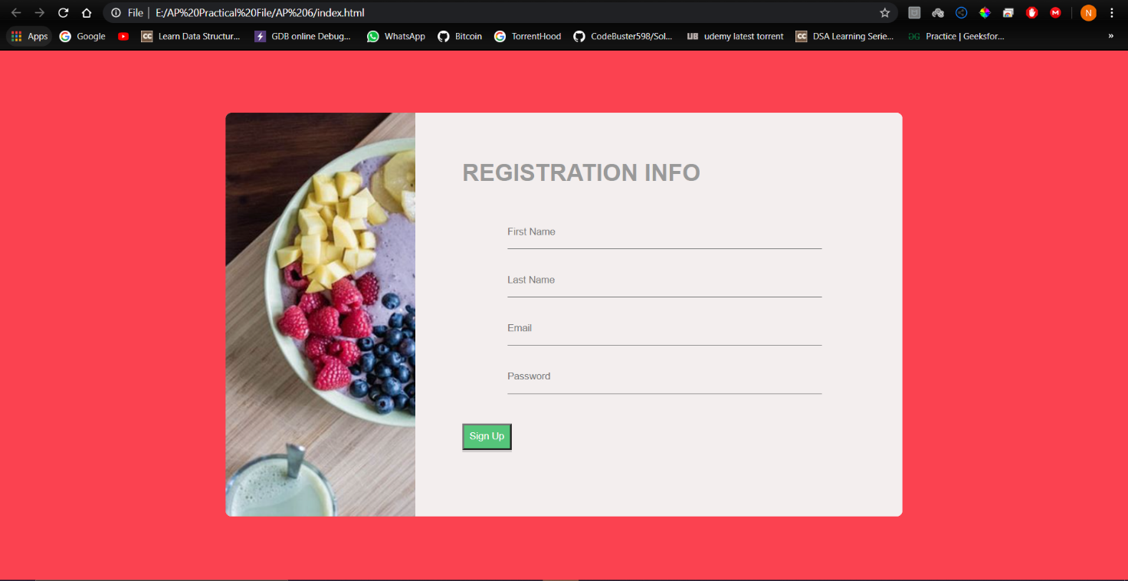OUTPUT (Page) :

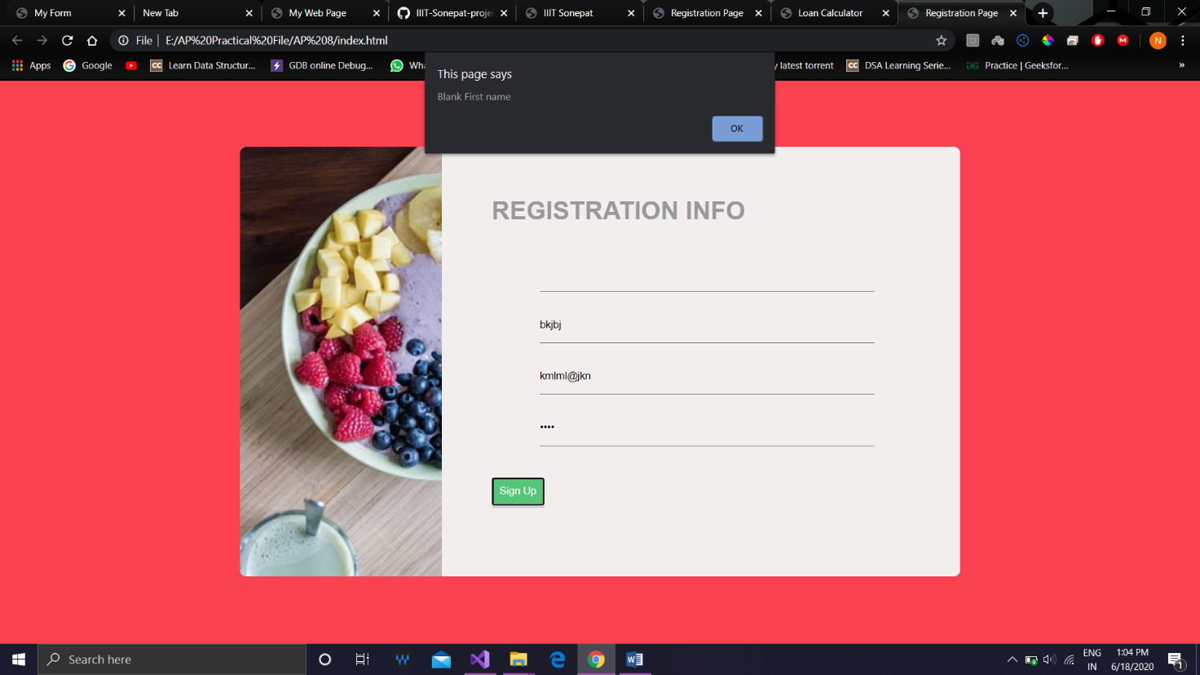OUTPUT (If first name is left blank) :

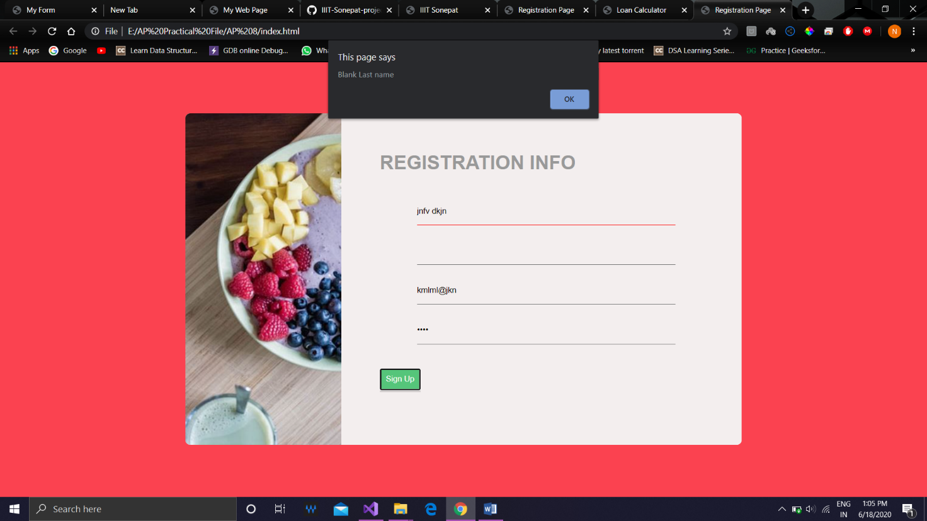OUTPUT (If last name is left blank) :

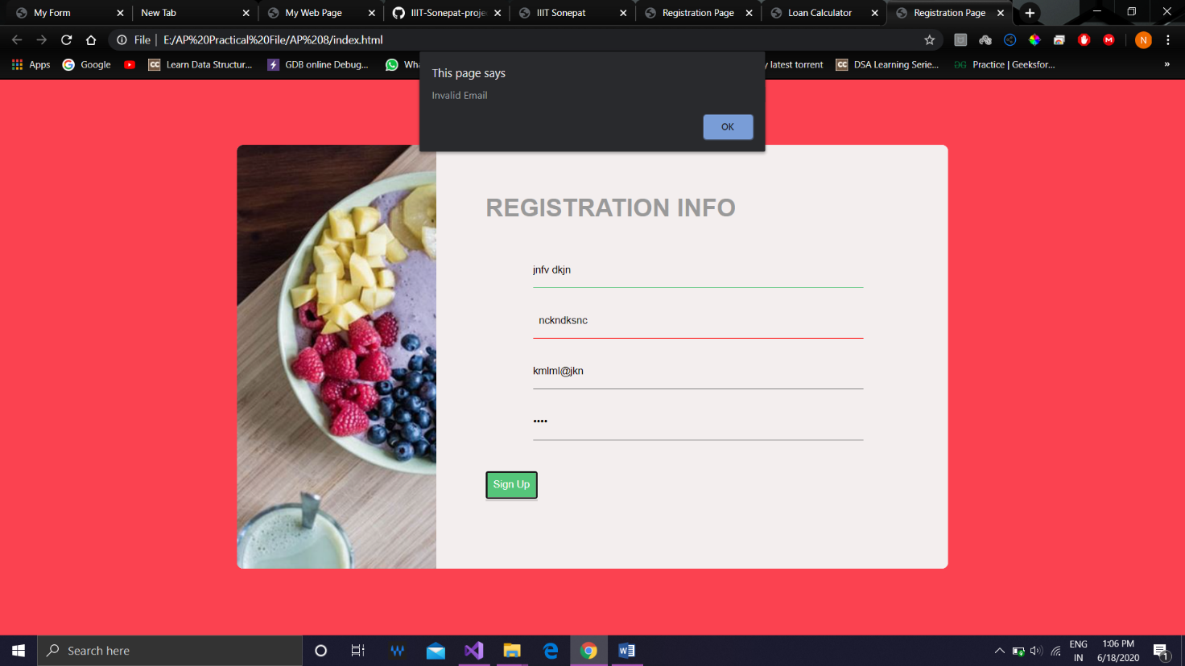OUTPUT (If invalid email is entered)

OUTPUT (If password entered is less than 8 characters) :

